**Project 1**

**<Lehr’s Lair>**

**CIS-17B**

**Heidi Dye**

**10/21/19**

**Introduction**

Title: Lehr’s Lair

Type: Click and Escape

Story: Midterm projects are due in the morning, but you have no idea how to start your code. Luckily, you overhear Dr. Lehr say that he has the code on a flash drive in in office. So, you decide to steal the flash drive that very night. Big Mistake. You get caught and awaken to find yourself in the trunk of a car. How will you escape?

Gameplay: The game will have three levels corresponding with three different rooms to escape from. The player first starts out in the trunk of a car, and they must escape from the inside of car. Next, the player has to escape from the garage the car was in, but the only way out is down. Down in the secret basement lair, the player must escape from the bowels of dusty computers and dead students in order to reach salvation. Each room will have various items that a player can use to escape. By clicking on a specific item, the player will then add that item to their inventory. Rooms do not build off of each other so each item found in that room will only help the player in that specific room.

**Walkthroughs**

**Trunk**

(Game start pitch black)

1. Click around until you open the back seat to cabin of the car
2. Open glove compartment to find flashlight
3. Inside console between front seats has batteries
4. Go back to trunk
5. Grab the wire cutters from the trunk
6. Look on the car door and look at the riddle
7. Underneath the steering wheel, there are three colored wires. Only cut the red wire to shut off the car alarm
8. Open the car door

**Garage**

1. Press switch to open garage door (moves but doesn’t open)
2. Obtain metal piece #1
3. Notice dark hole under car
4. Look at calendar
5. Find toolbox w/ combination lock & enter date from calendar
6. Obtain crowbar
7. Open stubborn cabinet with crow bar
8. Obtain kitty litter and flashlight
9. (Can now see in dark hole but determine it’s still too far to jump down)
10. Look under workbench
11. Find metal piece #2
12. Find oil spot
13. Pour kitty litter onto oil spot to reveal alpha code
14. Find lockbox
15. Put alpha code in lockbox
16. Find metal piece 3&4
17. Look at bumper of car
18. Obtain metal piece 5
19. Combine metal pieces to create ladder

**Basement**

1. Enter Basement
2. Pick up lit candle
3. Look for keyboard
4. Pick up keyboard
5. Access computer 1 unlocks Computers 2-5
6. Pick up flash drive that you tried to steal earlier on the floor by Computer 1
7. Find secret code back/side of Computer 2
8. Use code unlock terminal 3
9. Talk to caged student
10. Get clue for terminal 4
11. Reconnect terminal 4
12. Use clue on terminal 4
13. Pick up coolant for terminal 5
14. Use coolant to fix terminal 5
15. Unlocks cages for students
16. Grants cell key
17. Student gives exit key Grants exit key Exit and win

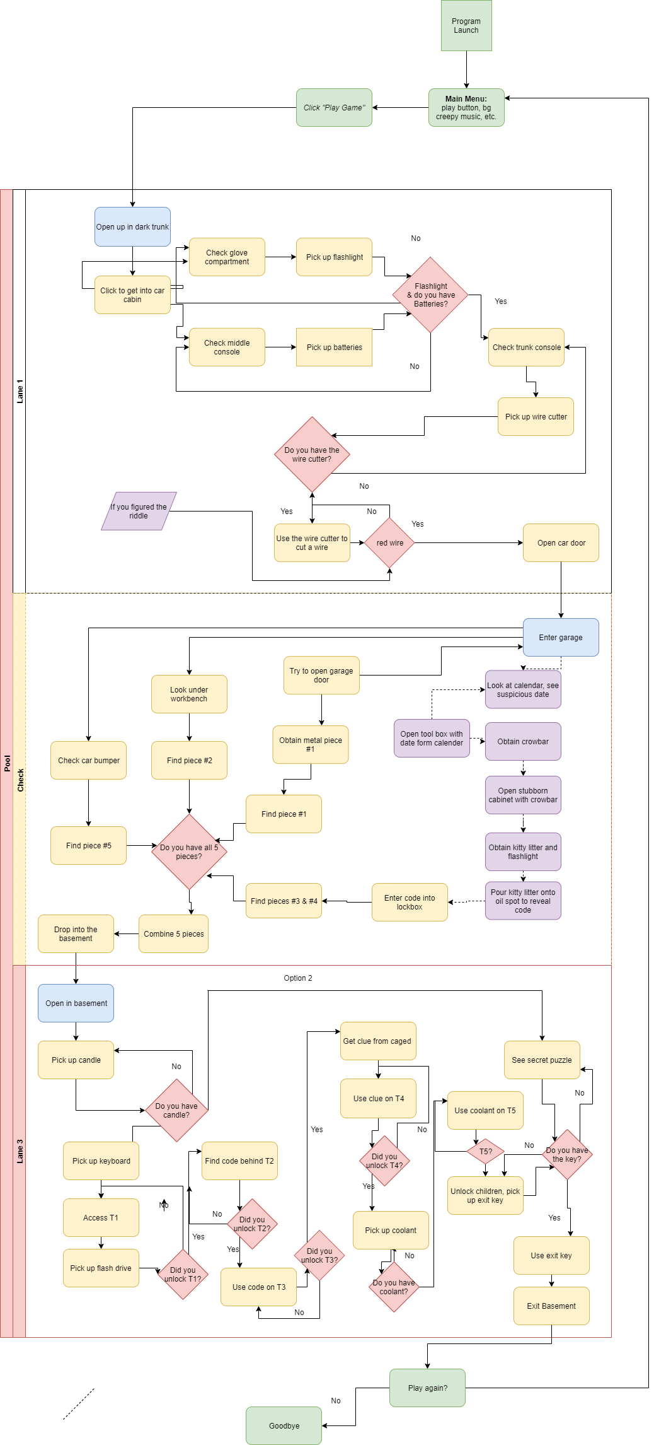**Flowcharts**



**Psuedocode**

1. Outer page will act as a game border and placeholder for the inventory items
2. Inner pages will act as the various rooms to escape from
3. Start the game
4. Set up the level with all the rooms
5. Set up the background images and hotspots for the pages or rooms
6. Read in the hotspots from a txt file
7. Check if an item (the coordinates) has been clicked
8. If clicked, set the inventory item as true and show the item in the inventory
9. Set the corresponding background image based on what inventory items are true
10. If an arrow has been clicked, move to the next room
11. If the player has gathered all the items and they can escape, then move them on to the next level of the game.
12. Repeat steps 4-10 until all the levels have been beaten

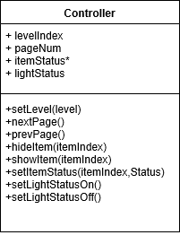**UML Diagrams**

**Code**

class Controller {

private $levelIndex;

private $pageNum;

private $itemStatus;

private $lightStatus;

const ITEM_NUM = 20;

function __construct() {

$this->levelIndex = 0;

$this->pageNum = 0;

$this->itemStatus = array(0, 0, 0, 0,

0, 0, 0, 0,

0, 0, 0, 0,

0, 0, 0, 0,

0, 0, 0, 0,);

$this->lightStatus = 0;

}

public function setLevel($level){

$this->levelIndex = $level;

//echo HTML

}

public function nextPage(){

$this->pageNum++;

//echo HTML

}

public function prevPage(){

$this->pageNum--;

//echo HTML

}

public function hideItem($itemIndex){

//echo HTML

}

public function showItem($itemIndex){

//echo HTML

}

public function setItemStatus($itemIndex, $status){

$this->itemStatus[$itemIndex] = $status;

}

public function setItemStatusOn(){

$this->lightStatus = 1;

}

public function setItemStatusOff(){

$this->lightStatus = 0;

}

}

?>

**Hotspots**

**Trunk**

Battery

"457,359,613,439"

Blue Wire

"408,225,617,605"

Door Handle

"685,351,905,498"

Down Arrow

"425,562,589,718"

Flashlight

"743,583,1025,689"

Glovebox 2

"1,104,472,411"

Glovebox

"633,115,931,244"

Green Wire

"621,250,888,613"

Left Arrow

"18,309,164,457"

Middle Console

"401,449,612,712"

Red Wire

"96,243,416,592"

Right Arrow

"881,305,1021,457"

Trunk Seat

"420,226,501,275"

Up Arrow

"432,7,593,134"

Wires

"134,215,402,375"

**Schedule**

Oct 23rd- Basics of clicking on items and adding them to the inventory for use

Oct 30th- Being able to use items from the inventory and finish the artwork for the game

Nov 6th- start on the Basement and the Garage

Nov 13th- Saving user data on a server. Make a high score for the fastest time.

Nov 20th- Work on the final touches of the game

Nov 27th-Game complete